# Database Design

## Description

A company has a website that informs the subscribers which brands are more eco-friendly. They would need a database for all their brand and the review. For each order brand, they would need title, total score, info, rating and how they were reviewed. The database needs to keep track of all brands that are being scored. Customers will have to input their information when registering an account.

## Business Reporting Requirements

Substitute in here the information the users of your application will want to be able to view.

1. Organisers need to be able to create, read, update, and delete: brands, clothing article, rating, role.
2. Users will need to be able to find all brands ordered by their clothing article.
3. Users need to find all brands for a specific clothing article.
4. Users need to find the rating for a specific brand.
5. Users need to find the rating for a brand.
6. Users need to find the review for a rating.

## Textual Representation of Data-Set

Substitute in here the tables for your database

**BRANDS** (id, title, info, image_path)

**CLOTHING_ARTICLE** (id, title, info, image_id)

**BRAND_ARTICLE** (id, brand_id, article_id)

**IMAGE** (id, filename)

**RATING** (id, brand_id, review_id, rating)

**REVIEW** (id, title, info)

**ROLE** (id, name, info)

**USER** (id, name, email, password)

**USER_ROLE** (id, user_id, role_id)

## Business Rules

Substitute in here the business rules for your database

• A **brand** has many **clothing articles**.

• A **clothing article** belongs to many **brands**.

• A **rating** has a **review**.

• A **review** is on one **brand**.

• A **user** can have many **roles**.

• A **role** can have many **users**.

• An **Image** can be associated with a **Brand**

## Entity Relationship Diagram

Substitute in here your ERD from draw.io

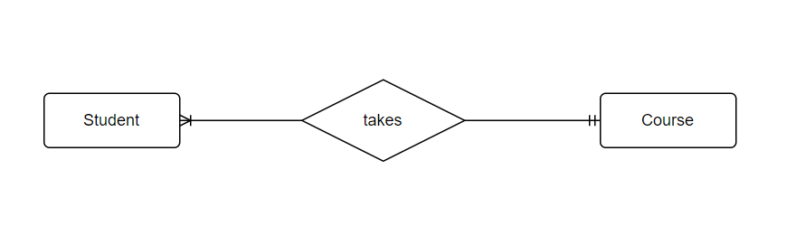

## Tables

Substitute in here your tables and the relationships between tables from draw.io in the format you used in DBMS with Mohammed.

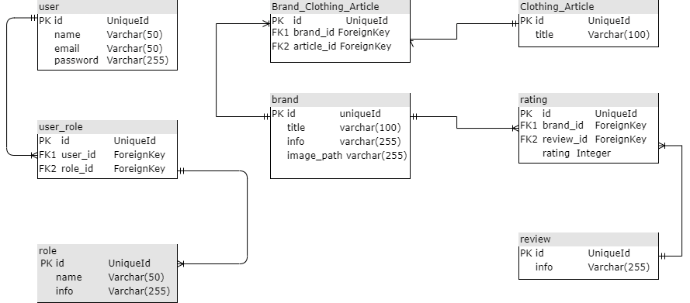

## Database Dictionary

|  |  |  |  |  |  |  |
| --- | --- | --- | --- | --- | --- | --- |
| Table | Attribute | Datatype | Range | Required | PK/FK | FK Ref Table |
| User | Id | BigInt |  |  | PK |  |
| User | Name | Varchar | 255 | Yes |  |  |
| User | Email | Varchar | 50 | Yes |  |  |
| User | Password | Varchar | 255 | Yes |  |  |
| User_role | Id | BigInt |  |  | PK |  |
| User_role | User_id | BigInt |  | Yes | FK | User |
| User_role | Role_id | BigInt |  | Yes | Fk | Role |
| Role | Id | BigInt |  | Yes | PK |  |
| Role | Name | Varchar | 50 | Yes |  |  |
| Role | Info | Varchar | 255 | Yes |  |  |
| Brand | Id | BigInt |  | Yes | PK |  |
| Brand | Title | Varchar | 100 | Yes |  |  |
| Brand | Info | Varchar | 255 | Yes |  |  |
| Brand | Image_path | Varchar | 100 | No |  |  |
| Clothing_article |  |  |  |  |  |  |
|  |  |  |  |  |  |  |
|  |  |  |  |  |  |  |

# System Design/ Architecture Overview

* 1. Introduction

This section will describe the internal functionality of the web framework that you have chosen for the implementation. Add further sections if required by the specification of your web application

* 1. Model View Controller

Explain the follows a model-view-controller design pattern and how it is implemented in your web application.

* 1. User Authentication

Explain how user authentication is implemented in the web application framework.

* 1. Routing

Describe the routes that were defined in the web application

* 1. Templating

Describe the templating engine and how it was used to configure/ style the web application.

Add a sequence diagram in this section and other diagrams that illustrate the architecture clearly.

